Ministry for Environmental Protection of Ukraine
Carpathian Biosphere Reserve
Swiss-Ukrainian forest development project in Transcarpathia (FORZA)

Ecological and Social-Economic Aspects of Ethnic-Cultural and Historical Heritage Conservation in the Carpathians

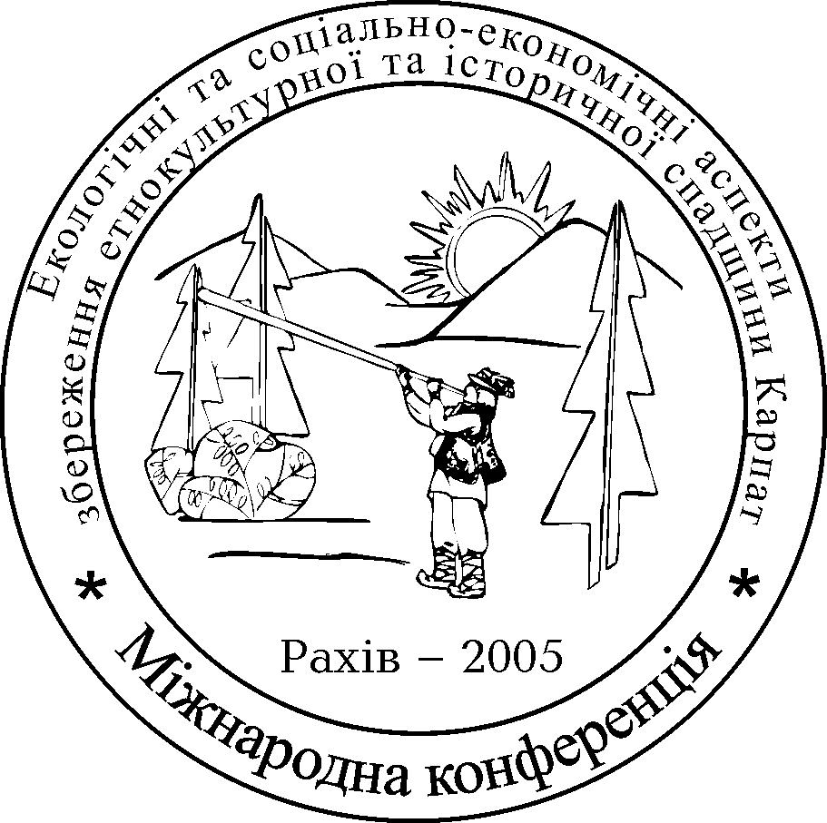

PROGRAM

of the International Conference

September 1 – 5, 2005

Rakhiv – 2005

Dear __________________________________________

_______________________________________________________

We cordially invite you to participate in the International Conference “Ecological and social-economic aspects of ethnic-cultural and historical heritage conservation in the Carpathians”, which will be held within the framework of the 15th International Hutsul Festival.

Best regards,
Organizing Committee

DRAFT PROGRAM

September 1

Arrival and lodging
Registration of participants
from 2 p.m. to 00:00 in the “Tysa” hotel
1, Franka St.

September 2

7 a.m. - 8 a.m. – breakfast

8 a.m - 9 a.m – registration (Rakhiv District State Administration, 1, Myru St.)

9 a.m. - 9 a.m. – Opening Session

Welcome and introduction.

9 a.m. – 11 a.m. – Plenary Session

Samolyotov P.V. Ethnic-cultural peculiarities of mountain dwellers as one of the factors of social-economic development of the Ukrainian Carpathians (Institute of Regional Investigations UNAS, Lviv, Ukraine)

Movchan Ya.I., Ivanenko І.B., Fyshko N.М., Bezusko А.H., Bodnarenko Yu.V. Carpathian Convention: collisions of intentions and reality (Ministry for Environmental Protection of Ukraine, Kyiv, Ukraine)

Foellmi H. Swiss-Ukrainian forest development project in Transcarpathia as an important factor of economical development and conservation of natural and cultural values of the Carpathians (Swiss-Ukrainian forest development project in Transcarpathia FORZA, Switzerland)

Shkriblyak P.V. Some specific issues of people’s life and labour organization under the conditions of the Carpathian highland and their interaction with social-economic, ethnic-cultural and state-forming processes in the region (Branch “Hutsulschyna” of Ukrainian Country-Study Scientific-Research Institute, Verkhovyna, Ukraine)

Voloschuk І. Role of international co-operation in conservation of natural and cultural heritage of the Carpathians (Carpathian Association of National Parks and Reserves, Slovak Republic)

Chornobai Yu.M. Sustainable development of the Hutsul Land in the context of ecological ethics. (National Nature Museum UNAS, Lviv, Ukraine)

Kolotylo Ya. Problems of the Ukrainians’ culture and traditions conservation in the Romanian Carpathians (Ministry of Culture of Romania, Bucharest, Romania)

Edman T., Angelstam P. Benchmarking landscapes of the Carpathians – a historical approach (Swedish University of Agricultural Sciences, Alnarp, Sweden)

11 a.m. – 11 a.m. – coffee break

11 a.m. – 12 a.m. – Plenary Session

Stoyko S.M. Alternative role of biosphere reserves, national parks and regional landscape parks in conservation of ethnic-cultural and historical heritage (Institute of Ecology of the Carpathians UNAS, Lviv, Ukraine)

Dutchak S.V. Two aspects of tourism infrastructure development impact upon conservation of ethnic originality in the Carpathian Mountains (Chernivtsi Commercial College, Chernivtsi, Ukraine)

Maryskevych O., Maryskevych T., Niewiadomski Z. Conservation of ethnic-cultural heritage within the Ukrainian part of BBR “Eastern Carpathians” (Institute of Ecology of the Carpathians UNAS, Ivan Franko National University of Lviv, Lviv, Ukraine; Bieszady Park Narodovy, Ustriki Gorne, Poland)

Bashta А.-Т. Significance of national traditions promotion for ethnic-cultural heritage conservation and environmental protection of mountainous regions (Institute of Ecology of the Carpathians UNAS, Lviv, Ukraine)

Chernous О.V. Impact of negative natural and technogenic processes upon the state of ethnic-cultural environment in the Ukrainian Carpathians (Institute of Regional Investigations UNAS, Lviv, Ukraine)

Chornenkyi Ya.Ya. The natural and the cultural in human consciousness (West-Ukrainian Institute of Information Technologies and Management, a branch of Donetsk National University of Management, Lviv, Ukraine)

Frink J.P., Petrean А. Some phytogeographic and vegetation peculiarities, customs and traditions in the Apuseni Mountains (Western Carpathians, Romania) (Babes-Bolyai University; Folklore Institute of Romanian NAS, Cluj-Napoca, Romania)

12 a.m. – 1 p.m. – presentation of a book by Lavruk М.М. “Hutsuls of the Ukrainian Carpathians”

13 p.m. – 14 p.m. – lunch

SECTION 1

Role of natural environment in formation of mountain dwellers’ spiritual and cultural values
Chair – Sukharyuk D.D.
Secretary – Bunyak V.І.

(2 p.m. – 3 p.m., Assembly Hall, RDSA)

Balazh N.Yo. Natural conditions and landscape peculiarities in Transcarpathia (Мukachevo State Agrarian Technical School, Mukachevo, Ukraine)

Bovych L.Yu. Impact of nature-territorial factors on formation of traditional Ukrainian way of life (Kosiv state Institute of Applied Arts, Kosiv, Ukraine)

Vatamanyuk D.M. Pip Ivan Mountain – religious background in the names of the Chornohora Mountain Range summits (Ukrainian Society “Hutsulschyna”, Verkhovyna, Ukraine)

Vepryk N.P., Buchko Zh.І. Influence of natural environment upon creation of Mediaeval historical architectural sites in the Ukrainian Carpathians (Yu. Fedkovych National University of Chernivtsi, Chernivtsi, Ukraine)

Haidukevych O. Nature protection in the Carpathian Mountains as one of the aspects of Ukrainian Greek-Catholic Church’s activity (V. Stefanyk Precarpathian National University, Ivano-Frankivsk, Ukraine)

Hamor A.F. Role of wild fruit plants in life and household of mountain dwellers of the Ukrainian Carpathians (Carpathian Biosphere Reserve, Rakhiv, Ukraine)

Horoshko L. Productive power of water (based on calendar customs and traditions of the Carpathian Region) (Folklore Institute UNAS, Lviv, Ukraine)

Zelenchuk Ya.І. Hunting and fishing traditions of the Hutsul Land (Branch “Hutsulschyna” of Scientific-research Institute of Ukrainian Country-Study, Verkhovyna, Ukraine)

Komar Zh.Yu., Shkurhan V.І., Yasidlov Yu.І. Image of a bear in the Hutsuls’ traditional crafts (Ivano-Frankivsk regional Society for Historical and Cultural Sites Protection, Ivano-Frankivsk; Society “Hutsulschyna”, Kosiv; Association “Nash Dim”(Our Home), Ivano-Frankivsk, Ukraine)

Lozynskyi R.М. On correlation of the two notions: “subethnos” and “ethnographic group” (in the context of investigation of the Hutsuls of the Ukrainian Carpathians) (I. Franko National University of Lviv, Lviv, Ukraine)

Mykhailyuk S.А. Nature and its role in human spiritual and cultural values formation (Institute of Natural Resources Management, Kolomiya, Ukraine)

Skrypnikova М., Shpakivska І. Ancient agricultural terraces as centers of conservation of traditional ways of land-use in mountainous regions of Eurasia (V. Dokuchaev Soil Science Institute Moscow, Russia; Institute of Ecology of the Carpathians, Lviv, Ukraine)

Sukharyuk D.D. Role of natural forests in the process of spiritual and cultural values formation (Carpathian Biosphere Reserve, Rakhiv, Ukraine)

Sukharyuk D.D., Bedei М.І. About traditional ways of nature use in the Ukrainian Carpathians (Carpathian Biosphere Reserve, Rakhiv, Ukraine)

SECTION 2

Impact of negative ecological and social-economic processes upon the state of ethnic-cultural originality conservation in the Carpathian Mountains

Chair – Byblyuk N.І.
Secretary – Shaban N.V.

(3 p.m. – 4 p.m. Assembly Hall of RDSA)

Bublyuk N.І. Impact of technogenic processes on the Carpathian natural landscapes as a harmonious ethnographic environment (Ukrainian National University of Forest and Wood Technology, Lviv, Ukraine)

Bundzyak Yo.Yo. Impact of tourism upon the ethnic originality of Ukrainian mountain dwellers (Carpathian Biosphere Reserve, Rakhiv, Ukraine)

Varyvoda І.Ye. Problems of commercial structures functioning within the tourist-recreation complex of the Carpathian Region (Mukachevo Technology Institute, Mukachevo, Ukraine)

Hazuda М.V. Social background for agrarian industry revival in the Carpathian Region (Uzhgorod National University, Uzhgorod, Ukraine)

Hamor F.D., Zakurenyi V.P., Bundzyak V.V. Project “Ecotourism development as an innovation mechanism for liferate improvement within local communities in mountainous Rakhiv district” (Carpathian Biosphere Reserve, Rakhiv District Council, Rakhiv, Ukraine)

Honcharuk V.Ye., Savula Ya.H., Torskyi А.R., Chaplya Ye.Ya. Mathematic and computer modeling of negative ecological processes’ impact upon the environment (Center for Mathematical Modeling UNAS, Ivan Franko University of Lviv, Lviv Polytechnic National University, Lviv, Ukraine)

Hryschenko V.F., Stoyko S.M., Sukharyuk D.D., Ecological analyses of snow avalanches’ impact in the Carpathian highland and the system of upper forest line protection (Ukrainian Scientific Research Institute of Hydrometeorology, Kyiv; Institute of Ecology of the Carpathians UNAS, Lviv; Carpathian Biosphere Reserve, Rakhiv, Ukraine)

Zhovynskyi E.Ya., Кryuchenko N.О., Маnichev V.Y., Кuraeva І.V. Problems of ecology of the Ukrainian Carpathians and ways of their solution (Institute of Geochemistry, mineralogy and ore-formation UNAS, Kyiv, Ukraine)

Zinkevych О.М. Geographic aspects of globalization processes and people’s culture interaction in the Ukrainian Carpathians (Ivan Franko National University of Lviv, Lviv, Ukraine)

Коsovets О.О., Samoylenko N.А. Catastrophic hydrological phenomena at the edge of centuries in the Ukrainian Carpathians (Central Geophysics Observatory, Kyiv, Ukraine)

Коstrytsya М.М. Tourism development as a means ethnic-cultural and historical heritage conservation (Zhytomyr State Technical University, Zhytomyr, Ukraine)

Lendel М.А., Hazuda L.М. Formation and development of human potential of agrarian sector in the Carpathian Region (Uzhgorod National University, Uzhgorod, Ukraine)

Маnivchuk Yu.V., Маteleshko О.H. Ecological and social-economic consequences of agrarian technical-intensive systems application in the Ukrainian Carpathians and ways of their reduction (Uzhgorod National University, Uzhgorod, Ukraine)

Kharchenko Т.А., Lyashenko A.V., Zorina-Sakharova K.Ye., Tsarenyuk Т.М. Biodiversity of water ecosystems and landscape changes in Transcarpathia (Institute of Hydrobiology UNAS, Kyiv, Ukraine)

Chornenka N.V. Specific features of recreation nature use and cultural heritage interaction (Lviv Ecological Polytechnical School, Lviv, Ukraine)

Shaban N.V. Initiative of FORZA Project on Transcarpathian Tourist Hiking Trial establishment (FORZA Project on Transcarpathian Tourist Hiking Trial’s Concept Elaboration; Transcarpathian Regional Center for Rural Tourism Development, Uzhgorod, Ukraine)

Shparyk Yu.S., Kundelska T.V. Evaluation of landscapes disturbance on mountain-skiing slopes in the Ukrainian Carpathians (hotel-tourism center “Bukovel” taken as an example) (Ukrainian Scientific Research Institute of Mountain Forestry; Ivano-Frankivsk National Oil and Gas Technical University, Ivano-Frankivsk, Ukraine)

Shushnyak V.М. Division of the Ukrainian Carpathians into regions based on tourism and country-study (Ivan Franko National University of Lviv, Lviv, Ukraine)

SECTION 3

Carpathian Convention as an important tool of international co-operation in the sphere of natural and cultural heritage conservation

Chair – Stadnytskyi Yu.I.
Secretary – Blyznyuk М.М.
(2 p.m.- 3 p.m., Lesser Assembly Hall RDSA)

Blyznyuk М.М. Advertising introduction of the Carpathian Convention in Hutsul Land through Internet (Kosiv State Museum of Applied Arts, Kosiv, Ukraine)

Borschuk Ye.М. Problems of social grounds of sustainable development criteria in mountain areas (Lviv Commercial Academy, Lviv, Ukraine)

Voytenko H.V. Demographic-labour potential in the context of sustainable development of the Carpathian Region (Uzhgorod National University, Uzhgorod, Ukraine)

Hamor F.D. Implementation of the Framework Convention on Protection and Sustainable Development of the Carpathians in Ukraine (Carpathian Biosphere Reserve, Rakhiv, Ukraine)

Hamor F.D., Vasidlov Yu.I. Notes to the problem of the National Mountains Committee (Carpathian Biosphere Reserve, Rakhiv; Association “Nash Dim” (Our Home), Ivano-Frankivsk, Ukraine)

Lazareva S.V. Ecological consciousness as a basic category of sustainable development (Chernivtsi Regional Institute of Postgraduate Pedagogical Education, Chernivtsi, Ukraine)

Stadnytskyi Yu.І. Comparative analyses of the Alpine and Carpathian Conventions (Politechnika Svietoksyska, Poland)

SECTION 4
Role of protected areas for ethnic-cultural
and historical heritage conservation

Chair – Pokynchereda V.F.
Secretary – Popovych H.I.
(3 p.m. – 4 p.m., Lesser Assembly Hall RDSA)

Veska J. Research of virgin forests on permanent plots established by Prof. Alois Zlatnik in Zakarpattya province, Ukraine (Mendel University of Agriculture and Forestry, Brno, Czech Republic)

Vytseha R.R Role of nature-protection fund of the Carpathian Region in biodiversity conservation (Ukrainian National Forest and Wood Technology University, Lviv, Ukraine)

Horb К.М. Problems of cultural and natural heritage sites’ value identification for delegation of various protection status (Customs Service Academy of Ukraine, Dnipropetrovsk, Ukraine)

Кruk D.Ye. National nature parks of the Hutsul Land and the Carpathian Biosphere Reserve as a geographic environment for the Hutsuls’ ethnic-cultural heritage conservation (Ivan Franko National University of Lviv, Lviv, Ukraine)

Kuchynska I.V., Kiselyk Yu.A. Perspectives of religious tourism development in Ukrainian Roztochchya (Yavorivskyi National Nature Park, Ivano-Frankove, Ukraine)

Mykitchak Т.І. The Chornohora lakes – past, present and future (Institute of Ecology of the Carpathians UNAS, Lviv, Ukraine)

Pokynchereda V.F. Museums of protected areas as a means of local ethnic-cultural heritage conservation (Carpathian Biosphere Reserve, Rakhiv, Ukraine)

Popovych H.I. Role of protected areas in ethnic-cultural and historical heritage protection (Yablunytsya secondary school, Yaremche, Ukraine)

Ryff L.Ye. Relicts of Mediterranean agriculture within protected areas of Crimean southern coast (Nikin Botanic Garden- National Scientific Center, Yalta, Ukraine)

Shapar A.H., Yemets М.А., Skrypnyk О.О. Role of Cossacks’ legends in designation of technogenic park “Kodatska Fortress” as an element of ecological network (Institute of Nature-Use and Ecology UNAS, Dnipropetrovs’k, Ukraine)

Steffek J., Gavlas V, Dudich A. Fauna of the Slovakian East Carpathians as a world natural heritage (Faculty of Ecology and Environmental Sciences, Banska Stiavnica, Slovak Republic)

Yakymchuk A.Yu. Characteristics of regional landscape parks within the structure on nature-protection fund of Rivne region and their significance in terms of history and culture (Natinal University of Water Resources and Nature Use, Rivne, Ukraine)

4 p.m. – 6:30 p.m. – Round Table

“Problems of the Carpathian Convention Implementation”

Chair – Vasidlov Yu. I.
Secretary – Herevych О.V.

4:30 – 6:30 – Poster Session

Aftanaziv I.S., Voloschuk M.D. Ecological problems of Hutsulschyna: an insight into the 3rd Millennium (Institute of Natural Resources Management, Kolomiya, Ukraine)

Bozhuk Т., Kruhlov І. Geoecological inventory of the model plot “Kvasnyi”, Ukrainian Maramorosh (Lviv National Polytechnic University, Ivan Franko National University of Lviv, Lviv, Ukraine)

Buzak L.Yu. Role of pupils and out-of-school clubs in biodiversity and Hutsul ethnic-cultural heritage conservation (Lazeschyna secondary school, NGO “Ecosphere”, Lazeschyna, Ukraine)

Bunyak V., Haidukevych M. Rare and endangered plants of the Carpathians in Hutsuls’ legends (V. Stefanyk Precarpahtian National University, Ivano-Frankivsk, Ukraine)

Vedmedenko D.V. Ecological education in the context of a personality-targeted model of education (Chernivtsi Regional Institute of Postgraduate Education, Chernivtsi, Ukraine)

Dmytruk Yu.M. Methodic aspects and problems of soil geochemic research in the Carpathians (Yu. Fedkovych Chernivtsi National University, Chernivtsi, Ukraine)

Dutchak M.V. Mountain river-valley landscapes and their role in mountain dwellers’ life (Yu. Fedkovych Chernivtsi National University, Chernivtsi, Ukraine)

Elbakidze М.М. Ways of traditional nature use conservation in national nature parks of the Ukrainian Carpathians (Ivan Franko National University of Lviv)

Zarnik М., Hruby Z. Research of dynamics of virgin forests on Yavornik Mt (The Forest Management Institute Brandýs and Labem, Frydek-Mistek, Czech Republic)

Zelenchuk І.М. Project “Carpathian Mountain Agrarian School” (Branch “Hutsulschyna” of Scientific Research Institute of Ukrainian Country-Study, Verkhovyna, Ukraine)

Kozurak A.V., Lazutkin H.H. Scientific-cognitive and educational significance of rare and Red Data Book species collection plot in the Carpathian Biosphere Reserve (Carpathian Biosphere Reserve, Rakhiv, Ukraine)

Kosylo L.S. Nature-study excursion as a means of ecological education (Carpathian National Nature Park, Yaremche, Ukraine)

Kostrytsya M.Yu. Historical heritage of Slovechansko-Ovruchskyi Mountain Ridge: reality and prospectives of optimal use (Zhytomyr Regional Institute of Postgraduate Education, Zhytomyr, Ukraine)

Minchenko T.A. Forms and methods of ecological education in schools by means of Ukrainian country-study (Chernivtsi Regional Institute of Postgraduate Education, Chernivtsi, Ukraine)

Nahirnyi M.B. History of Vorokhta in persons: S. Fedak, S. Salyk and the others (V. Stefanyk Precarpathian National University, Ivano-Frankivsk, Ukraine)

Stehnei М.І. Problems of credit relations improvement in the agrarian sector of Ukrainian economy (Мukachevo Technical Institute, Mukachevo, Ukraine)

Styranivskyi О.А. Reduction of rut depth and soil disturbance caused by forestry machines (Ukrainian National Forest and Wood Technology University, Lviv, Ukraine)

Pelypeiko I.А. About the national fairy in Kosiv (Кosiv, Ukraine)

Pipash L.І. Hydrochemichal regime of water sites as an indicator of natural ecosystems’ state in the Carpathіan Biosphere Reserve (Carpathian Biosphere Reserve, Rakhiv, Ukraine)

Pohrebnyi A.L., Solodova L.B. Мineral waters as a constitutive part of natural recreation potential of the Carpathian Biosphere Reserve (Ukrainian Scientific Research Institute of Medical Rehabilitation, Odesa, Ukraine)

Romanovych R.А., Lendel М.А. Development of land relations in the Ukrainian Carpathians (Uzhgorod National University, Uzhgorod, Ukraine)

Fedorenko L.M., Fedorenko A.P. Informal ecological education in the conditions of village schools in the Carpathian Region (Chernivtsi Regional Institute of Postgraduate Education, Chernivtsi, Ukraine)

Chaskovskyi О.H. Application of some elements of artificial intellect during forest massifs monitoring in Chornohora based on data of remote sensing (Ukrainian National University of Forest and Wood Technology, Lviv, Ukraine)

6:30 p.m. – 7 p.m. – adoption of the Resolution, close-up

20⁰⁰ – social event - dinner

September 3 – 4

Participation in the events of the 15th International Hutsul Festival

September 5

Departure

© Editor - the Carpathian Biosphere Reserve, 2005
77, Krasne Pleso St., Rakhiv 90600, Transcarpathian reg., Ukraine
Tel. +38 (03132) 2-21-93; tel./fax +38 (03132) 2-26-59
100 copies

